**DESIGN AND DEVELOPMENT OF “BLOOD NEARBY”: AN ANDROID BASED MOBILE APPLICATION**

**by**

**HABIBUL HAQUE**

**ID: 133-15-2944**

**AND**

**SIFAT HOSEN**

**ID: 133-15-2882**

This Report Presented in Partial Fulfillment of the Requirements for the Degree of Bachelor of Science in Computer Science and Engineering

Supervised By

**Narayan Ranjan Chakraborty**

Professor and Head

Department of CSE

Daffodil International University

Co-Supervised By

**Nazmun Nessa Moon**

Assistant Professor

Department of CSE

Daffodil International University



**DAFFODIL INTERNATIONAL UNIVERSITY**

**Dhaka, Bangladesh**

**September 2017**

**APPROVAL**

This Project titled **“Design and Development of “Blood Nearby”: An Android Based Mobile Application**”, submitted by Habibul Haque and Sifat Hosen to the Department of Computer Science and Engineering, Daffodil International University, has been accepted as satisfactory for the partial fulfillment of the requirements for the degree of B.Sc. in Computer Science and Engineering and approved as to its style and contents. The presentation has been held on 12/09/2017.

**Board of Examiners**

**Dr. Syed Akhter Hossain Chairman**

**Professor and Head**

Department of Computer Science and Engineering

Faculty of Science & Information Technology

Daffodil International University

**Dr. Sheak Rashed Haider Noori Internal Examiner**

**Associate Professor and Associate Head**

Department of Computer Science and Engineering

Faculty of Science & Information Technology

Daffodil International University

**Md. Zahid Hasan Internal Examiner**

**Assistant Professor**

Department of Computer Science and Engineering

Faculty of Science & Information Technology

Daffodil International University

**Dr. Mohammad Shorif Uddin External Examiner**

**Professor**

Department of Computer Science and Engineering

Jahangirnagar University

**DECLARATION**

We hereby declare that; this project has been done by us under the supervision of of **Narayan Ranjan Chakraborty, Assistant Professor, Department of CSE,** Daffodil International University. We also declare that neither this project nor any part of this project has been submitted elsewhere for award of any degree or diploma.

**Supervised by:**

**Mr. Narayan Ranjan Chakraborty**

**Assistant Professor**

Department of CSE

Daffodil International University.

**Submitted by:**

**Md. Habibul Haque**

ID: 133-15-2944

Department of CSE

Daffodil International University

**Sifat Hosen**

ID: 133-15-2882

Department of CSE

Daffodil International University

**ACKNOWLEDGEMENT**

We express our heartiest thanks and gratefulness to almighty Allah as His divine blessing makes us possible to complete the final year project successfully.

We felt grateful to and wish our profound our indebtedness to **Narayan Ranjan Chakraborty, Assistant Professor,** Department of Computer Science and Engineering, Daffodil International University, Dhaka. Deep Knowledge & keen interest of our supervisor in the field of Mobile Apps development (android based) influenced us to carry out this project. His endless patience, scholarly guidance, continual encouragement, constant and energetic supervision, constructive criticism, valuable advice, reading many inferior draft and correcting them at all stage have made it possible to complete this project.

We would like to express our heartiest gratitude to **Dr. Syed Akhter Hossain, Professor and Head,** Department of Computer Science and Engineering, for his kind help to finish our project and to other faculty member and the staff of Computer Science and Engineering department of Daffodil International University.

We would like to thank our entire course mate in Daffodil International University, who took part in this discuss while completing the course work.

Finally, we must acknowledge with due respect the constant support and patients of our parents

**ABSTRACT**

Now a day, the prominence of smart phone is expanding quickly. Smart phone is only a specialized device yet additionally a basic piece of our day-by-day life. Presently the android platform is ending up increasingly famous in the hardware advertise. Since, android is an open source portable working platform with huge client base and improved versatile application advancement process.

In this project, we have built up an android base application for all individuals of our nation who require crisis blood. The main purpose of the “Blood Nearby: An Android Mobile Application for Searching Blood” is to make better solution for blood seekers and blood contributors. This application is beneficiary for blood seekers to handle the critical situation. User can search donors at his/her nearest location when necessary by using this application. They can create his/her own profile and user can make his/her contact number private. The App will also help users to find their desire blood from popular blood bank of our countries. We have used Java and XML for front-end designing and Firebase for back-end design. In the wake of finishing all task, the application tested in various stages and was discovered working effectively.

**TABLE OF CONTENTS**

|  |  |
| --- | --- |
| **CONTENTS** | **PAGE** |
| Board of examiners | i |
| Declaration | ii |
| Acknowledgements | iii |
| Abstract | iv |
| **CHAPTER** |  |
| **CHAPTER 1: INTRODUCTION** | **1-2** |
| 1.1 Introduction | 1 |
| 1.2 Motivation | 1 |
| 1.3 Objectives | 1 |
| 1.4 Expected Outcome | 2 |
| 1.5 Report Layout | 2 |
| **CHAPTER 2: BACKGROUND** | **3-6** |
| 2.1 Introduction | 3 |
| 2.2 Related Works | 3 |
| 2.3 Comparative Studies | 5 |
| 2.4 Scope of the Problem | 5 |
| 2.5 Challenges | 6 |
| **CHAPTER 3: REQUIREMENT SPECIFICATION** | **7-10** |
| 3.1 Business Process Modeling | 7 |
| 3.2 Requirement Collection and Analysis | 8 |
| 3.2.1 Functional Requirement | 9 |
|  |  |

|  |  |
| --- | --- |
| 3.2.2 Non-functional Requirement | 9 |
| 3.3 Use Case Modeling And Description | 9 |
| 3.4 Logical Data Model | 10 |
| 3.5 Design Requirements | 10 |
| **CHAPTER 4: DESIGN SPECIFICATION** | **11-20** |
| 4.1 Front-end-Design | 11 |
| 4.2 Back-end Design | 16 |
| 4.3 Interaction Design and UX | 18 |
| 4.4 Implementation Requirements | 19 |
| 4.4.1 Android Studio | 19 |
| 4.4.1.1 Basic Android Overview | 19 |
| 4.4.2 The Emulator | 19 |
| 4.4.3 Android SDK | 20 |
| 4.4.4 Firebase | 20 |
| **CHAPTER 5: IMPLEMENTATION AND TESTING** | **21-32** |
| 5.1 Implementation of Database | 21 |
| 5.1.1 Database Design | 21 |
| 5.1.2 Storing Process of Data | 22 |
| 5.2 Implementation of Front-end Design | 24 |

|  |  |
| --- | --- |
| 5.3 Implementation of Interactions | 29 |
| 5.4 Testing Implementation | 30 |
| 5.5 Test Results and Reports | 32 |
| **CHAPTER 6: CONCLUSION AND FUTURE SCOPE** | **33** |
| 6.1 Discussion and conclusion | 33 |
| 6.2 Limitations | 33 |
| 6.3 Scope for Further Development | 33 |
| **APPENDIX** | **34** |
| **REFERENCES** | **35** |

**LIST OF FIGURES**

|  |  |
| --- | --- |
| **FIGURES** | **PAGE NO** |
| Figure 2.1: Blood Finder | 4 |
| Figure 2.2: Blood Life | 4 |
| Figure 2.3: Blood Bank Bangladesh | 5 |
| Figure 3.1: Data Flow Diagram of the propose system. | 7 |
| Figure 3.2: Waterfall Model. | 8 |
| Figure 3.3: Use Case Modeling. | 9 |
| Figure 3.4: Logical Model. | 10 |
| Figure 4.1: Splash UI. | 11 |
| Figure 4.2: Registration Activity. | 12 |
| Figure 4.3: Login Activity. | 12 |
| Figure 4.4: All Available Users. | 13 |
| Figure 4.5: Searching Donor by Blood Group. | 13 |
| Figure 4.6: Searching Donor by Blood Address. | 14 |
| Figure 4.7: Searching Donor by Blood Map. | 14 |
| Figure 4.8: Searching Donor by Blood Bank. | 15 |
| Figure 4.9: Private User. | 15 |
| Figure 4.10: User Authentication Table. | 16 |
| Figure 4.11: User Authentication Rules Table. | 17 |
| Figure 4.12: User Table. | 17 |
| Figure 4.13: UID Table. | 17 |
| Figure 4.14: User Information. | 18 |
| Figure 4.15: Private User Information. | 18 |
| Figure 5.1: User Authentication Table. | 22 |
| Figure 5.2: User Authentication Rules table. | 22 |

|  |  |
| --- | --- |
| Figure 5.3: User Table | 23 |
| Figure 5.4: UID Table. | 23 |
| Figure5.5: User Information Table. | 24 |
| Figure 5.6: Private User Information Table. | 24 |
| Figure 5.7: Registration Activity. | 25 |
| Figure 5.8 Login Activity | 26 |
| Figure 5.9 All Available Users | 26 |
| Figure 5.10: Searching Blood by Blood Group. | 27 |
| Figure 5.11: Searching Blood by Blood by Address. | 27 |
| Figure 5.12: Searching Blood by Blood by Map. | 28 |
| Figure 5.13: Searching Blood by Blood by Blood Bank. | 28 |
| Figure 5.14 Private User | 29 |
|  |  |
|  |  |
|  |  |
|  |  |
|  |  |
|  |  |
|  |  |

**LIST OF TABLES**

**TABLE PAGE**

Table 1: Implementation test results and reports……………………..……...30

Table 2: Comparison of feedback and usability……………………………...34

**CHAPTER 1**

**INTRODUCTION**

**1.1 Introduction**

“Blood” is a word that every patient or relative of a patient knows. In our daily life, every hospital needs a lot of blood for blood seeker patient. Sometimes they manage bloods from the blood bank. Most of the time if patient needs blood then he/she have to manage it from their relatives or any other source. But, it’s not easy to manage blood in time and for this reason many patients have died. So to make blood searching easy we are making a Google Android Platform application. If you have a smart android device, you will be able to search any blood group via using this application.

“BloodNearby” is an android base mobile application that is work as a communication medium between two types of user. One of those who need emergency blood and other is who gives blood.

In this application user has to sign up with his basic information and also with his blood group. By this application user can find blood donors and contact with them. He can search based on location and blood group when he/she need donor from specific location in an emergency situation.

**1.2 Motivation**

If we see the statistic then we can see in every three seconds one people need blood worldwide. And if we see look for our country then we can see in every hospital they need blood. We see relatives of the patient are seeking for blood. They search for everywhere. But sometimes they don’t get proper response or feedback within that short time. So considering the circumstances we want to make something that will help our country’s people. We want to make something that will help them find blood donor easily. So we planned to make this kind of application. That’s the motive behind our project.

**1.3 Objectives**

Objective of Our mobile application are mentioned bellow:

* To provide a platform by which anyone can find a blood donor easily.
* To provide the donor who is in the nearest location from the blood seeker.
* To provide the information about many blood donation organizations those maybe help them for blood collecting.

**1.4 Expected Outcome**

”Blood Nearby” is an android based mobile application that is developed to search blood donor who is nearest to the blood seeker. The final outcome of this app is to find the blood donor in critical moment. When a blood seeker need a blood donor within a short time then he/she search for who is nearest to him/her and at this time this app will help them for searching the blood donor. We hope this application will help the user to get more beneficiary information about blood donation and also about organizations those are working on blood transfusion activities.

**1.5 Report Layout**

In chapter 1 of the report we introduce our project application and discussed about motivation, objective and also its expected outcome.

In chapter 2 of the report, we discuss about the background circumstances of our project. We also talk about the related work, the scope and challenges of the project and the comparison to many other candidate systems.

In the chapter 3, we specified the requirement of the project. In this section we defined the data flow diagram use case, ER diagram and design requirements. We also discussed about the requirement collection and analysis process.

In the chapter 4, we specified the front end and the back end design of the project.

In the chapter 5, we exhibited the implementation of the whole project and we tested the every section of the project weather the application is working as expected.

In the chapter 6, we discussed about conclusion and the scope for further development of the project.

At last of the report, we give the related reference to ensure that the information in the report are must be correct.

**CHAPTER 2**

**Background**

**2.1 Introduction**

Today in the created world, most blood benefactors are unpaid volunteers who give blood for a group supply. In poorer nations, built up provisions are restricted and benefactors as a rule give blood when family or companions require a transfusion (coordinated gift).Transfusion of blood product is necessary for lifesaving intervention. More than 85 million units of blood are collected and transfuse every year worldwide. Blood units are used across variety of medical and surgical situation. For instance approximately 30% of critical care patients, and more than 50% of cardiac surgery patients, will receive a transfusion of blood during their hospital stay. Every day, many people who are suffering from serious injuries, such as from car crashes, war, terrorism or natural disasters need blood transfusion to replace blood lost during the injury, and also some people need blood because of his/her illness. Considering all these situations, we tried to develop a blood transfusion related project that helps the people of our country to find the blood donors easily. From the realization of these situations we are encouraged to build this application [1].

**2.2 Related Work**

In the recent work we have found some mobile application in Google play store.

**2.1.1 Blood Finder:** Blood Finder is an app with the addresses of many blood banks in Bangladesh. It also shows the map of Blood bank [2].

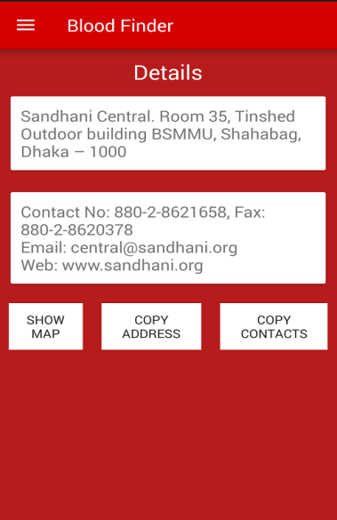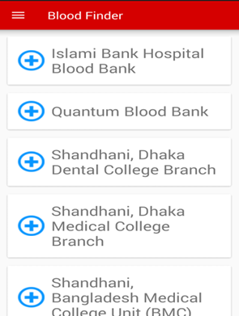

Figure-2.1 Blood Finder

**2.1.2 Blood Life:** Blood Life is the app where user can find the donor and not have to go any blood bank. From this app user will get the information about the donor from blood seeker’s districts [3].

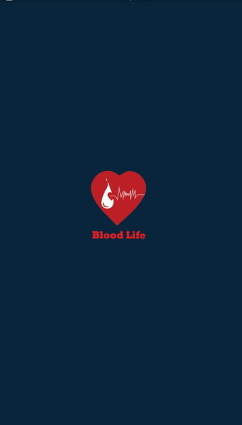 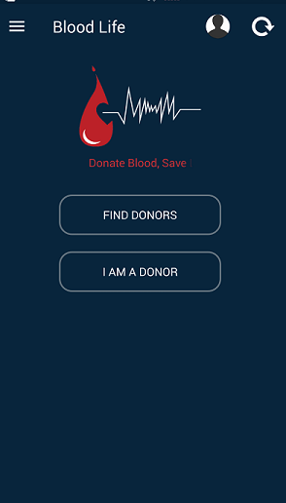 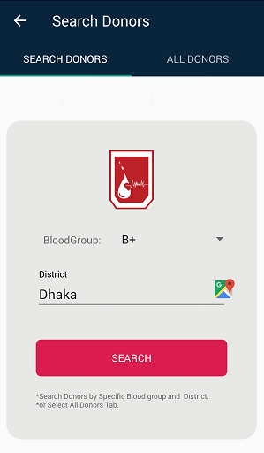

Figure 2.2 Blood Life

**2.1.3 Blood Bank Bangladesh:** It is a static app where user just finds the contact information about the Blood donor [4].

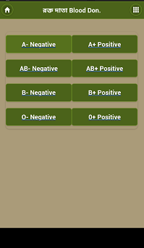 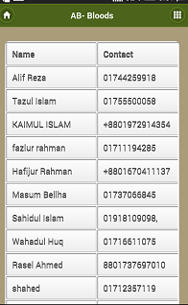`

Figure 2.3 Blood Bank Bangladesh

**2.3 Comparative Studies**

Those apps are helpful for people. They give the information about the blood bank or blood donors. But there are some limitations. Most of those apps are static type app. So they don’t give the real-time solution. When the blood seeker need blood immediately but there are now way to know who is the nearest blood donor. But in our app we try to fix all of the limitations. At first it is no more static app. In our app we use firebase for real-time database. Though it doesn’t show the blood donors information without internet but from the statistic of 2016 we see more than 20 million of the people in our country use internet so we think that will be no more problem. Without the internet it shows only the blood bank information. In our app we use the map and by using it the blood seekers could see who the nearest blood donor is. We think it will be helpful for immediate situation.

**2.4 Scope of the problem**

In our app we try to make it simple and user friendly with simple sign in and sign up system. And the features are also very simple. In our app it has an option for direct call so blood seekers may give direct call to blood donors. Here sometimes we face some problem for female with their contact information so there has an option for contact information in private mode. If the blood donors want so they can make their contact information in private mode. When they are in private mode then the blood seeker give them an urgent message with one click for make contact with them. Thus the users make their contact information also secure.

**2.5 Challenges**

When you want to do something then definitely you have to face some challenges and obstacles. Thus our project has some challenges too. Our project is about blood donation. All we know about the unwillingness of our people about blood donating. So if the people don’t donate blood so it will be hard to collect the data.

And on the other hand all of us addicted with Instagram, snap-chat and many other social media so it will hard to take place some times for it. All those things might be challenging for us.

**CHAPTER 3**

**Requirement Specification**

**3.1 Business Process Modeling**

Business process modeling is a technique for representing the workflow of a system. Diagram base as “flow diagram”, are the main characteristic of the methodology. Here we define our business model using Data Flow Diagram. Data Flow Diagram describes how data is processed through a system. In the figure we try to draw a level-1 Data Flow Diagram for our system. Figure 3.1 shows the Data flow diagram of the system.

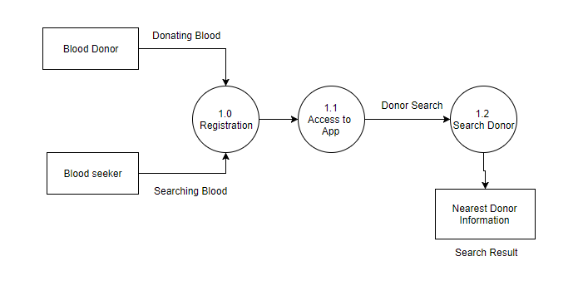

Fig 3.1: Data Flow Diagram of the system.

**Waterfall Model**

The Waterfall model was the first process model. It is also shows as linier sequential life cycle which is shown in Figure 3.2. It is a sequential software development process, in which progress is seen as flowing steadily downwards through the phase of Conception, Initiation, Analysis, Design, Construction, Testing and Maintenance.

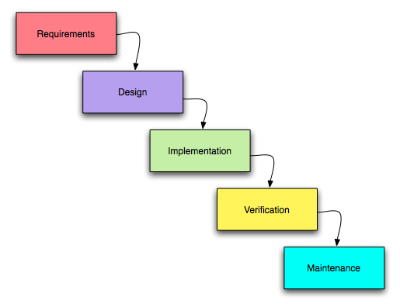

Figure 3.2: Waterfall Model

**3.2 Requirement Collection and Analysis**

Requirement collection and analysis is one of the primary conditions of application development. For deployment, there are two types of requirements, one is the functional requirement and the other is nonfunctional requirement. Functional requirements is those activities that's the application software can perform. On the other hand, Nonfunctional requirements define the personality of an application, as like the application is how much efficient, performance issue of the application and many more.

**3.2.1 Functional Requirement** From the point of view of our system, it should have many functional requirements like, a registration section, a login section where only authenticate person can access, a dashboard for maintaining user profile.

**3.2.2 Non-functional Requirement** Non-functional requirements are help to being more efficient; optimize performance, memory consuming, smoother operation, and load on quickly as possible to our application. Application UI should be user friendly and gorgeous for excellent user experience.

**3.3 Use Case Modeling and Description**

Figure 3.3 shows the Use Case Modelling.

A use case has these characteristics:

* Organize functional requirements.
* Models the goals of system/actor interactions.
* Record path from trigger event to goals.

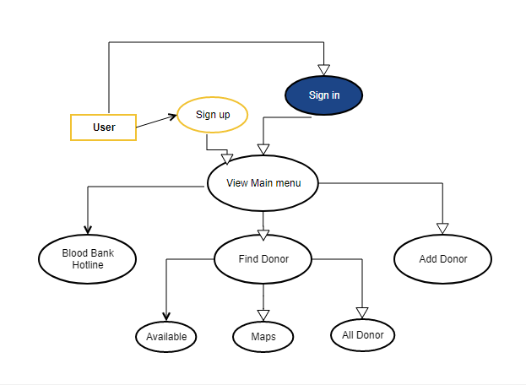

Figure: 3.3 Use Case Modelling

**3.4 Logical Data Model**

As a database we use Firebase. The structure for firebase is given in Figure 3.4.

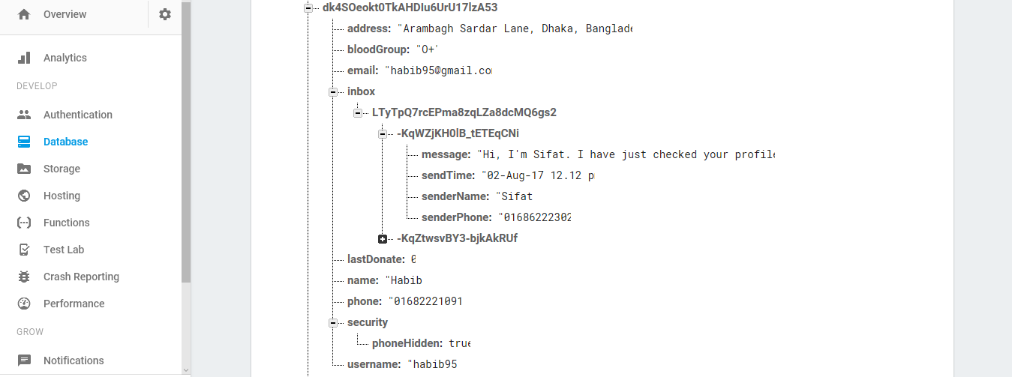

Figure 3.4: Logical Model

**3.5 Design Requirements**

The design requirements for our project will differ us from the other projects, because our project will working on our specific problem statement and the product, system, or experience that we are designing. We designed our project for a specific segment, that is blood donation and we try to provide the all things to our application that are necessary for a user to operate our application easily.

* In our application we design a registration so that any user can be registered to our application with their information.
* We design a donor search option where blood seekers can search with specific blood group.
* We design a map and by using it user can see who the nearest blood donor is.
* We design an option for make the contact information private.

**CHAPTER 4**

**Design Specification**

**4.1 Front-end Design**

From the perspective of designing, Front-end is the most essential segment for the application development. It is chipped away at introduction layer and user can directly communicate with this. It is essential to build up a straightforward and effectively understanding front-end or GUI for the user of the application. Therefore, we tried to keep our design as simple as possible and easily accessible for the user, but the development task was not so easy. We attach our application's front-end design as follows:

In figure 4.1 it shows the splash screen.

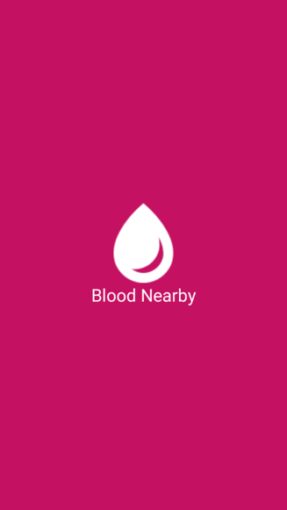

Figure 4.1: Splash UI.

In Figure, 4.2 show the registration window of our application. It’s a prerequisite process of our application. If someone wants to be a user of this application, they should register him or her first.

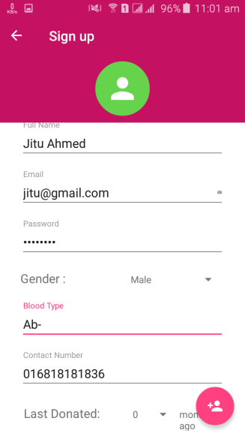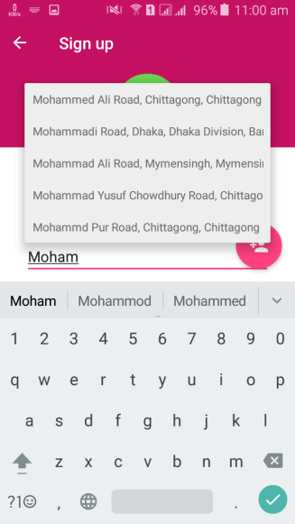

Figure 4.2: Registration Activity.

In Figure, 4.3 show our login widow that contains two mandatory fields one is email and other is password.

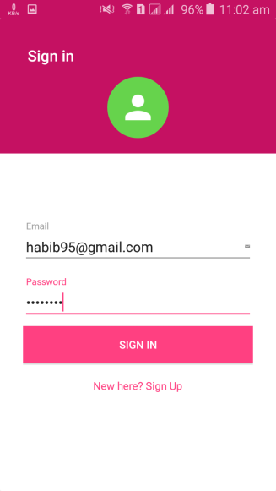

Figure 4.3: Login Activity.

In Figure, 4.4 show the all available users in the database.

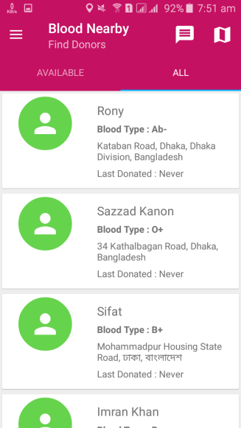

Figure 4.4: All available users.

In Figure, 4.5 shows searching donor by blood group from the database.

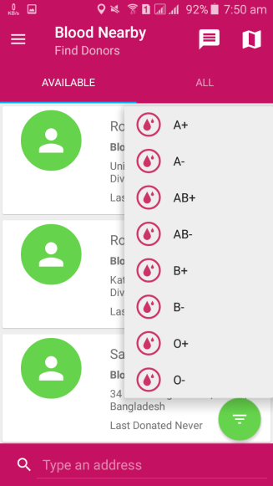

Figure 4.5: Searching Donor by Blood Group.

In Figure, 4.6 shows searching donor by address from the database. By using it anyone can find blood donor from specific area.

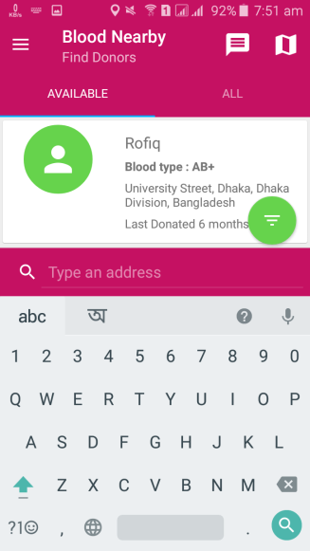

Figure 4.6: Searching Donor by Address.

In Figure,4.7 shows searching donor by maps from the database. By using it anyone can find the nearest blood.

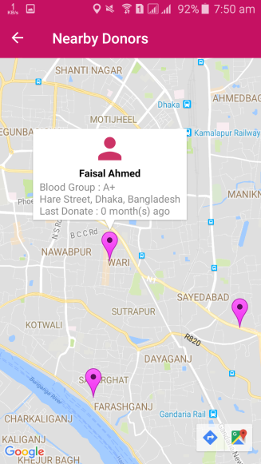

Figure 4.7: Searching Donor by Google Map.

In Figure, 4.8 shows searching donor by blood from the blood bank. The user can find only the contact information of some blood banks from here.

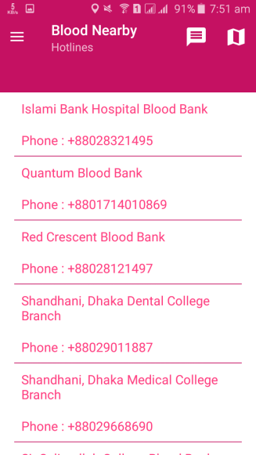

Figure 4.8: Searching Blood from Blood Bank.

In Figure, 4.9 show the private user option. By use it anyone can make his contact information in private.

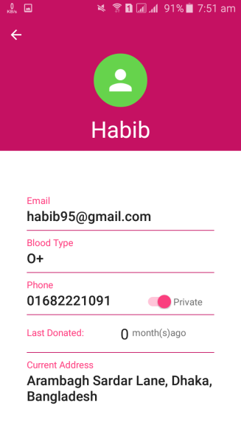 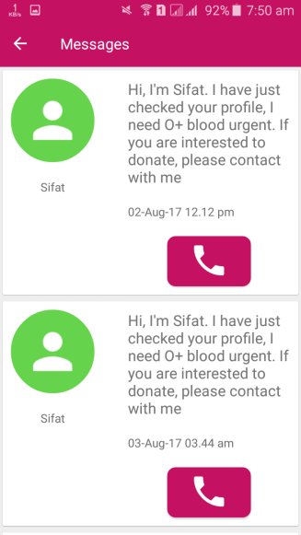

Figure 4.9: Private User.

**4.2 Back-end Design**

Back-end is the part that working behind the project, but the user is not notify or cannot see this part. Actually front-end design is only way to interact with the user but user cannot watch and never visualized how to this part is working. Back-end does everything that happens on the server or behind the application. For android application, it is more difficult to handle back-end part than a web application, because android device components are very limited. That is the reason; we have not created anything that could be reason for pressurized on the device in the back-end partition.

On our application, we use Firebase database to develop and maintain the back-end section. We attach our application's front-end design as follows:

Figure 4.10 shows the User Authentication Table. It shows how user authenticate occurs.

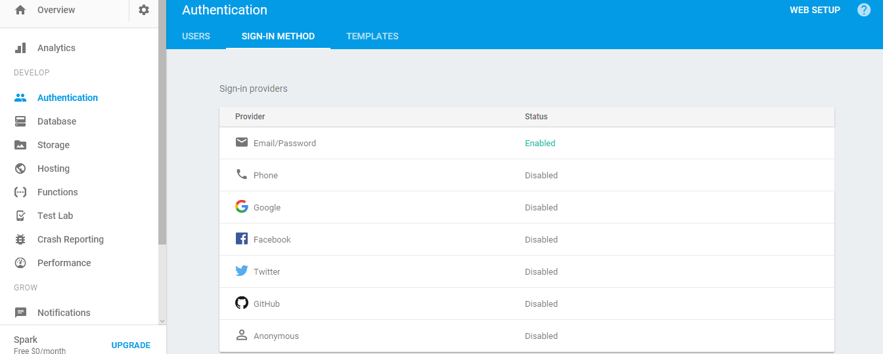

Figure 4.10: User Authentication Table.

Figure 4.11 shows the User Authentication Rules table.

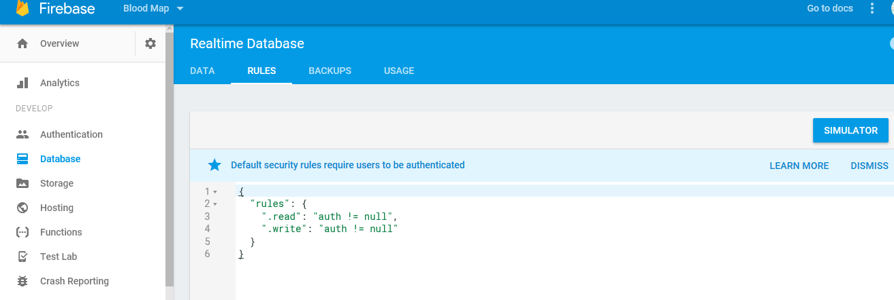

Figure 4.11: Authentication Rules Table.

Figure 4.12: shows the User table. It contains the user data.

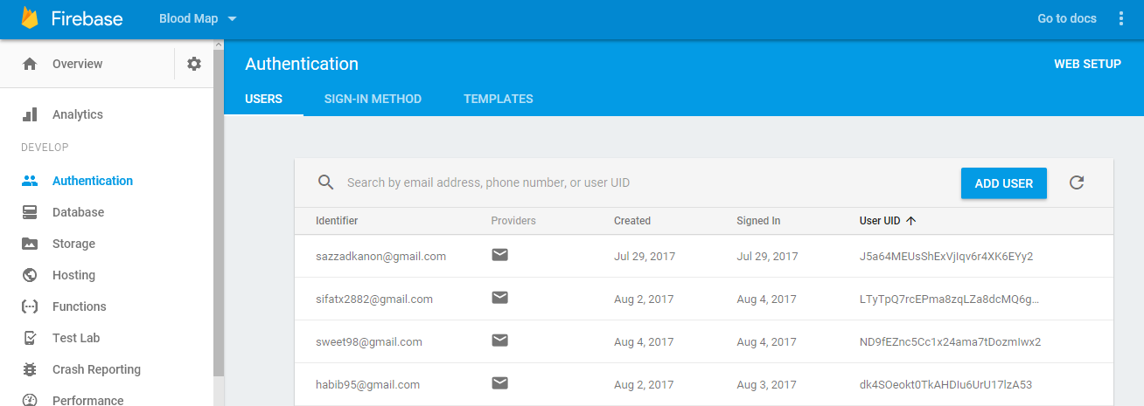

Figure 4.12: User Table.

Figure 4.13 shows UID Table. When a user signed up on our application, he/she has given a UID by our system.

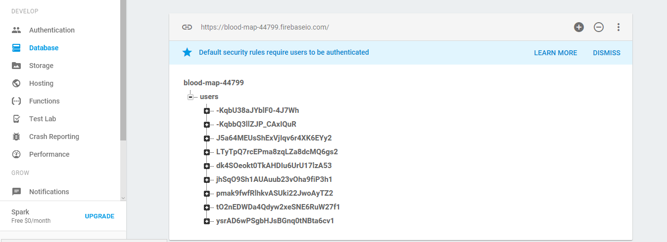

Figure 4.13: UID Table.

Figure 4.14 shows the User Information. It contains every user’s information without the user who makes their contact info private.

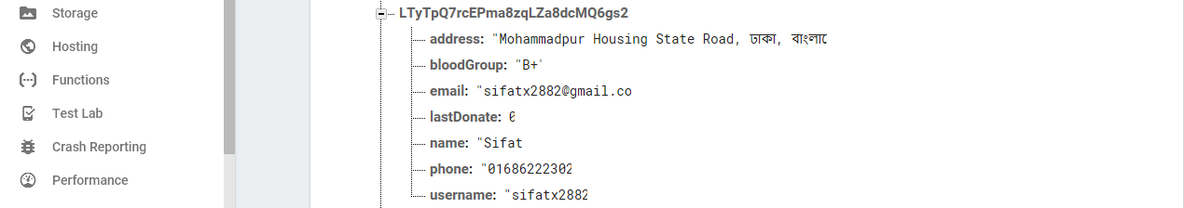

Figure 4.14: User Information.

Figure 4.15 shows the private User Information. It contains the information of users who make their information in private.



Figure 4.15: Private User Information.

**4.3 Interaction Design and UX**

Interaction design is teach that watches the connection between a framework and its user. All things considered association configuration is the procedures which comprehend the user issue space, process the issue and discover the outcomes, perform activities by the regarding comes about and take care of the issue.

On the other hand, user experience focuses on the overall experience between a user and an application. In our application, some features can interact with the user. In our application we added an option by which one user can make his/her contact number private, many of us don’t want to use this type of application for lack of security and for this reason we use this features so that people use our application comfortably.

For UX we have tried to give some fantastic experience by our application. We keep our system simple and easier for better experience and performance for the user.

**4.4 Implementation Requirements**

To implement our project we used different type of tools, components those help us to developed our project successfully. In Implementation Requirement section, we discussed about all those tools that we have used to develop our project.

**4.4.1 Android Studio**

Android studio gives the speediest apparatuses to building applications on each kind of Android gadget. Excellent code altering, troubleshooting, execution tooling, an adaptable form framework, and a moment fabricate/send framework all enable you to concentrate on building novel and superb applications. We utilize the Android Studio as our application IDE. Since here we discussing the Android Studio, so at first we have to know some essential data about Android [5].

**4.4.1.1 Basic Android Overview**

Android convey a total arrangement of programming for android devices. It has championed by Google and owned by Open Handset Alliance. Android is a comprehensive platform, which means it is a complete software stack for a mobile device. It provides all the tools frameworks for developing mobile apps quickly and easily. Android is also open source platform, so user can easily develop different mobile application by use it.

**4.4.2 The Emulator**

Running our application on a physical device versus an emulated device is pretty much the same thing. Because the emulator is an actual code emulator, meaning it runs the same code base as the actual device.

**4.4.3 Android SDK**

To develop Android application, Android SDK is the essential tool. This SDK is very comprehensive tool that contains not only the library for development, but also includes the simulator to test the application. We use Android studio together to run and develop all the Android application.

**4.4.4 Firebase**

To develop our application we have used firebase as our data manager. The Firebase Real-time Database is a cloud-hosted database. Data is stored as JSON and synchronized in real time to every connected client. When you build cross-platform apps with our iOS, Android, and JavaScript SDKs, all of your clients share one real-time Database instance and automatically receive updates with the newest data [6].

**CHAPTER 5**

**Implementation and Testing**

**5.1 Implementation of Database**

The database implementation phase is where you install the DBMS on the required hardware, optimize the database to run best on that hardware and software platform, and create the database and load the data.

**5.1.1 Database Design**

For storing our applications data, we used Firebase. Firebase has some facilities like real-time Database, Crash reporting, Authentication, Hosting, Cloud storage and so on. For these facilities, we have used firebase in our application. Data is persisted locally, and even while offline, real time events continue to fire, giving the end user a responsive experience. When the device regains connection, the real-time Database synchronizes the local data changes with the remote updates that occurred while the client was offline, merging any conflicts automatically.

The real-time Database provides a flexible, expression-based rules language, called Firebase real-time Database Security Rules, to define how your data should be structured and when data can be read from or written to. When integrated with Firebase Authentication, developers can define who has access to what data, and how they can access it.

The real-time Database is a NoSQL database and as such has different optimizations and functionality compared to a relational database. The real-time Database API is designed to only allow operations that can be executed quickly. This enables you to build a great real-time experience that can serve millions of users without compromising on responsiveness. Because of this, it is important to think about how users need to access your data and then structure it accordingly.

**5.1.2 Storing Process of Data**

After sign up process when the user want to login our application then they have to give the specific email by which he/she sign up on our application if he/she give a wrong email address then user can’t log in because we authenticate users by enabling email/password option. This process has imposed for password too. Firebase authentication table is given bellow:



Figure 5.1: User Authentication Table.

When any user gives wrong email address or wrong password firebase, do not allow this user for log in to our application. If any user gives wrong information in our application firebase use a rules for authenticate them. The authentication rules table is given bellow:



Figure 5.2: Authentication Rules Table.

In our application when a user get registered by their information and get successfully approval to log in then this user automatically created in user table. All the information of this user is stored here in the user table. The user table of our application is given bellow:



Figure 5.3: User Table.

When a user signed up on our application, he/she has given a UID by our system. By against this UID all information of this user would be saved in our database. The UID table is given bellow:



Figure 5.4: UID Table.

By this way all information of a user will be save on our database. This is a sequential tree by which all information of a user will be saved. A user information table is given bellow:



Figure 5.5: User Information.

In our application, we have used an option by which one user can make his/her contact number private. When a user do his/her contact number private if anyone want to contact with this private user then he/she have to send a request message through our application. In this case our database look like picture a bellow:



Figure 5.6: Private User Information.

**5.2 Implementation of Front-end Design**

Since android gadgets are littler in estimate, so the plan ought to be characterized in no time including key part of the framework. It’s very challenging to develop a gorgeous front-end design. Because, for developing a design for android devices, all the time u have to consider the display dimension of android device, it’s very tough to balance the design with android display size. For interactive design, we always try to be simple in UI design and we try some material design for make the application beautiful. But the most challenging portion is, to make our application, device independent, because there are many type of Smartphone that support android, among them some device have very week headwear component, in small pressure those devices behave like weird. Beyond different device can be different in version. So we have to design a system which can support all the devices and we have to ensure that, the system that support most of the android version from newer to older and doesn’t create any extra pressure on the devices. We attached our application front-end implemented design below.



Figure5.7: Registration Activity.

In Figure, 5.7 show the registration window of our application. It’s a prerequisite process of our application. If someone wants to be a user of this application, they should register him or her first. All the field of this window is required, so user must provide all data to register him, it’s a process to being a valid user for our system and another interesting part of our application is when a user types their address then our application suggest him/her to select address from suggestion bar.



Figure 5.8: Login Activity.

In Figure, 5.8 shows our login window that contains two mandatory fields one is email and other is password, to enter the system user must to be authenticate first, authentication process as mentioned earlier.



Figure 5.9: All available users.

In Figure, 5.9 describe our main user interface. Here one can find all available donor of our system. From this interface, one can find their desire blood and contact with donor for seeking blood.



Figure 5.10: Searching Donor by Blood Group.

In Figure 5.10, one can search a donor by using blood group if donor is available. If a user selects any blood group then our system find desire blood group for this user.



Figure 5.11: Searching Donor by Address.

In Figure 5.11 one user can find a donor by using their desire address. For this searching just type the desire address and our system will give you this specific addresses available donor.



Figure 5.12: Searching Donor by Google Map.

In Figure 5.12 a user can see the available donor of his/her nearest area and user can also contact with their nearest donor with their contact number very easily.



Figure 5.13: Searching Blood from Blood Bank.

In Figure 5.13 shows the Blood Bank window, from where blood seekers can get so many blood banks’ information and communicates with those organizations.

 

Figure 5.14: Private User.

In Figure 5.14 is describing the private user case. When a user makes his/her phone number private then nobody can see this user phone number if anyone wants to contact with him/her user must to send a request message. When a user send a request message the private user will contact this blood seeker user.

**5.3 Implementation and Interaction**

The architecture of a software system defines that system in terms of components and interactions among those components.

In real world, interaction can found almost everywhere. Interaction is the key to make a system dynamic and attractive to user. It’s very necessary to make a system interactive and we also try to. As mentioned in earlier, we also include some unique feature to interact our system. Our application is successfully implemented and the interaction of our application with the users is quiet impressive.

**5.4 Testing Implementation**

Table 5.4: Test Case for Blood Nearby.

|  |  |  |  |  |  |
| --- | --- | --- | --- | --- | --- |
| **Test Case** | **Test Input** | **Expected Output** | **Actual Output** | **Result** | **Tested On** |
| 1.Install Application | Tested on various Android version -   * Jelly Bean (4.1- 4.3.1)   · KitKat (4.4- 4.4.4)  · Lollipop (5.5-5.0.2)   * Marshmallow(6.0)   · Nougat (7.0-7.1) | Successfully Install all those versions. | Install successful. | Passed | 05/08/  2017 |
| 2. Registration | Without Registration. | To Restrict to access the Emergency Blood Search System features. | Imposed the Restriction. | Passed | 05/08/  2017 |
| 3. Email or Password | Blank or incorrect email or password | To warn that correct email or password must be entered. | Showed the warning. | Passed | 05/08/  2017 |
| 4. Password | Blank or incorrect password. | To warn that correct password must be entered. | Showed the warning. | Passed | 05/08/  2017 |
| 5. Profile | Click on the Profile button. | To show the user profile. information. | Showed user Profile. information successfully. | Passed | 05/08/  2017 |
| 6. Make contact  private | Click on the Private button | Contact number will be hidden. | Contact number remains hidden successfully. | passed | 05/08/  2017 |
| 7. Search Donor by using Blood Group | Click Desire Blood group. | To show the Desire Blood holder. | Showed the donor profile successfully. | passed | 05/08/  2017 |
| 8. Search Donor by using Map | Click the Map button. | To show the donors in nearest location. | Showed the donors profile successfully. | passed | 05/08/  2017 |
| 9.Contact Donors from Map | Click on donors profile in Map | To show the donors profile and contact details. | Showed the donors details successfully. | passed | 05/08/  2017 |
| 10. Send request to private user. | Click on request button to send a message to a private user. | Send a request message to donor. | Send a request message successfully to a user. | passed | 05/08/  2017 |
| 11. Search Donor by writing Location name. | Input the desire location. | To show the desire locations donor. | Showed the donors profile successfully. | passed | 05/08/  2017 |
| 12. Blood Bank | Click on the button Blood Bank button. | To show the blood bank list. | Show the blood bank list successfully. | passed | 05/08/  2017 |
| 13. Sign out | Click on the Sign out button. | To logout from that account. | Logged out Successfully. | passed | 05/08/  2017 |

**5.5 Test Results and Reports**

Test report is needed to reflect testing results in a formal way, which gives an opportunity to estimate testing result quickly. It is a document that records data obtained from an evaluation experiment in an organization manner, describe the environmental or operating conditions, and shows the comparison of test results with objectives.

In chapter 5.4, we shown the test case, test input, expected output, actual output and finally we find our results and the test result was quite successful. The user satisfies our application. Usability testing examines the following feature of the app.

* + - How easy it is to use the application?
    - How easy it is to learn the application?
    - How convenient is the application to end-user?

So at the end we can carry out the results as the benefits of usability testing to the end of the user or learner.

* + - Better quality application.
    - Application is easier to use.
    - Application is more readily accepted by users.
    - Shortens the information for the new users.
    - Better UI for interaction.
    - Some innovative idea for the blood seekers and donors.

**CHAPTER 6**

**CONCLUSION AND FUTURE SCOPE**

**6.1 Discussion and Conclusion**

Android based mobile application has been successfully implemented. We testing it with many devices and it worked perfectly and give the desired data. This application design is very user friendly so everybody who has the minimum knowledge about smartphone can easily use it.

We are encouraged to developing this kind of application because we see any people had to suffer a lot because of lacking of blood and they didn’t find blood in right time. Though they contacted with some blood bank but it didn’t give them the proper feedback. So we try to solve this problem in a digital way. We know most of the people of our country use internet Now-a-days. In our country more than 20 million people using internet according to the survey of 2016. We are living in the era of modern technology. Now everything is based on Computer science and Information technology. So why not this problem?. We initiate this project as an android application, with that we hope people will get desired service.

**6.2 Limitations**

Our application has some limitation. We will overcome those limitations in future. Some of the main limitations are –

* We only developed for android application
* We use firebase so without internet blood seeker couldn’t find the donor information.
* GPS need to be included.

**6.3 Scope for Future Developments**

* In future we try to make this application for all platforms.
* We try to add GPS so the blood seeker will find the current location of the donor.
* We will add more additional features to make it more dynamic to satisfy larger organizations

**Appendices**

**Appendix A: Project Reflection**

The purpose of this appendix is to provide an introduction to **Project Reflection.** This project was very challenging and enjoyable to us. We enjoy developing it. We understand many things during the developing period.

We were constantly developing and refining one another’s ideas. It was fascinating just how productive our group meetings were. The time seemed to fly and yet we always got a lot done and managed to help another along the way towards the endpoint of having a substantive policy.

Table A1 : comparison of feedback and usability.

|  |  |  |  |  |
| --- | --- | --- | --- | --- |
| SL NO | Name | Downloads | Rating | Feedback |
| 1 | Blood Life | 350 | 5 | -Thanks for this app.  -Useful. |
| 2 | Blood Finder | 1100 | 4.2 | -Need Dynamic .  -App crashes |
| 3 | Blood Nearby | 48 | 5.0 | - User friendly.  -Want to find data without internet.  - Easy to use.  . |

**REFERENCES**

[1] Klein H. G, Spahn D. R, Carson JL., “Effect of blood donor characteristics on transfusionoutcome.” Internet: https://www.ncbi.nlm.nih.gov/pmc/articles/PMC3998188, Mar. 28, 2014 [last accessed: Mar. 26, 2017]

[2] “Blood Finder (For BD).” Internet: https://play.google.com/store/apps/details?id=umpiredeveloper.bloodfinder [last accessed: Aug. 01, 2017]

[3] “Blood Life (For BD).” Internet: <https://play.google.com/store/apps/details?id=com.monsterking.android.BloodLife> [last accessed: Dec. 06, 2016]

[4] “Blood Bank Bangladesh (For BD).” Internet: https://play.google.com/store/apps/details?id=com.didar.mobile.bloodbankbd [last accessed: Jul. 12, 2017]

[5] “Android Studio.” Internet: https://developer.android.com/studio/index.html [last accessed: Aug. 1, 2017].

[6] “Firebase.” Internet: https://classroom.udacity.com/courses/ud0352 [last accessed: Aug. 4, 2017].

**Plagiarism**

